Q1 (a)

500/294 = 1.7006
500/203.84 = 2.4529
500/176.62 = 2.8309
500/164.92 = 3.0317
Q1(b) Calculate the values for the Karp-Flatt metric. Furthermore, also interpret the results of Karp-Flatt metric and write your opinion accordingly.

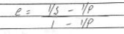
((1/1.70) – (1/2)) / (1 – 1/2) = 0.18
((1/2.45) – (1/4)) / (1 – 1/4) = 0.21
((1/2.83) – (1/6)) / (1 – 1/6) = 0.22
((1/3.03) – (1/8)) / (1 – 1/8) = 0.23
Since ‘e’ is increasing with p, it suggests that parallelization overhead is also contributing to the poor speedup. Hence, we need to reduce this overhead to improve speedups.

Q2(a)

Diameter = log₂ (p) = log₂ (16) = 4
Bisection width = p/2 = 16/2 = 8
Arc connectivity = log₂ (p) = log₂ (16) = 4
Cost = (p * log₂ (p) ) / 2 = (16 * log₂ (16)) / 2 = 32
Q2(b)

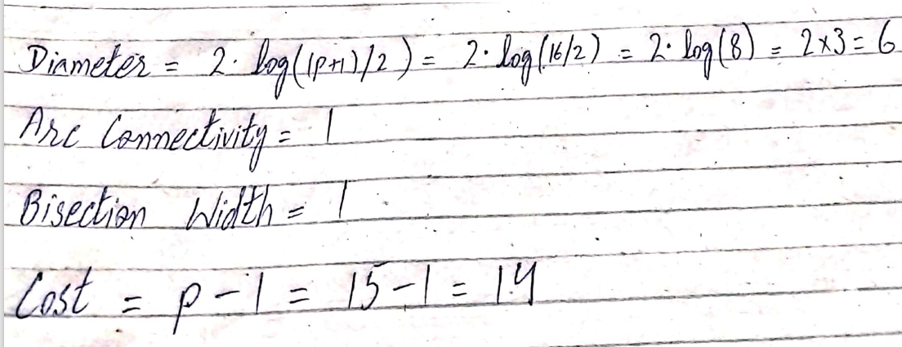

Q3: (a) Maximum degree of concurrency = 4
(b) Total Amount of Work = 50
(c) Critical Path Length = 25
(d) Average degree of concurrency = 2
(e)

Tasks having corresponding weights 2, 8, 9, 6 may be mapped to Pa
Tasks having corresponding weights 7, 1 may be mapped to Pb
Tasks having corresponding weights 3, 4, 10 may be mapped to Pc

Q4.
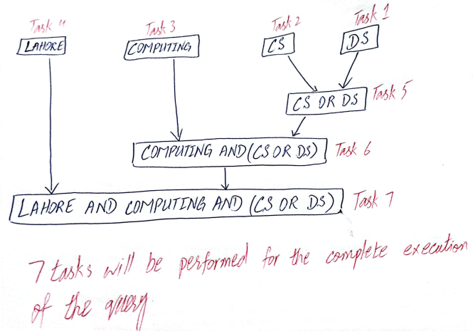

Q5 (a)
static long num_steps = 100000;
double step;
void main ()
{
int i; double x, total, sum = 0.0;
step = 1.0/(double) num_steps;
for (i = 0; i < num_steps; i++){
x = (i + 0.5) * step;
sum = sum + 1.0/(1.0 + x + x * x + x * x * x * x);
}
total = step * sum;
}

Q5 (b)

static long num_steps = 100000;
double step;
#define NUM_THREADS 4
int main(int argc, _TCHAR* argv[]) {
int i, nthreads;
double total, sum[NUM_THREADS];
step = 1.0/(double) num_steps;
omp_set_num_threads(NUM_THREADS);
#pragma omp parallel
{
int i, id, nthrds;
double x;
id = omp_get_thread_num();
nthrds = omp_get_num_threads();
if(id == 0)
nthreads = nthrds;
for (i=id, sum[id]=0.0; i< num_steps; i=i+nthrds){
x = (i+0.5)*step;
sum[id] += 1.0/(1.0 + x + x * x + x * x * x * x);
}
}
for(i=0, pi=0.0; i < nthreads; i++)
total += sum[i] * step;
printf("%f\n", total);
return 0;
}

